Java Object-Oriented Programming Experimental Report
NO: Experiment 8 Experiment name：Inheritance
Student ID | 1607052230 | Name | 邱冠霖 | Class |  | 16软工1班
Location | 实1-218 | Teacher | 唐朝辉 | Time |  | 20180504
1.Experimental purposes and requirements
1.1 Inheritance
1.2 Adapter Classes
1.3 Animation
2.Experimental equipment (environment) and requirements
2.1 Eclipse
2.2 Window XP
3.Lab Exercises(Please see Lab Manual)
3.1 Exploring Inheritance
3.2 A Sorted Integer List(Choose to do)
3.3 Test Questions (Choose to do)
3.4 Overriding the equals Method (Choose to do)
3.5 Extending Adapter Classes
3.6 Rebound Revisited
3.7 Count Down(Choose to do)
4.Experimental results and data processing

5.Analysis and discussion
没有遇到什么问题，源代码都放在github上，欢迎讨论
https://github.com/kong1414/JavaLesson.git
6.Teacher Reviews  Signature：  Date： |  |  |  |  | Score:

Experimental Report List
1 Exploring Inheritance
1) Source code list
package chapter08;
/**
* @Description:
* @Author: QiuGuanLin
* @Date: 2018/5/18 10:17
*/
public abstract class Dog {
protected String name;
// ------------------------------------------------------------
// Constructor -- store name
// ------------------------------------------------------------
public Dog() {
}
public Dog(String name) {
this.name = name;
}
// ------------------------------------------------------------
// Returns the dog's name
// ------------------------------------------------------------
public String getName() {
return name;
}
// ------------------------------------------------------------
// Returns a string with the dog's comments
// ------------------------------------------------------------
public String speak() {
return "Woof";
}
public abstract int avgBreedWeight();
}

package chapter08;
/**
* @Description:
* @Author: QiuGuanLin
* @Date: 2018/5/18 10:18
*/
public class Labrador extends Dog {
private String color;
//black, yellow, or chocolate?
private int breedWeight = 75;
public Labrador(String name, String color) {
super(name);
this.color = color;
}
// ------------------------------------------------------------
// Big bark -- overrides speak method in Dog
// ------------------------------------------------------------
@Override
public String speak() {
return "WOOF";
}
// ------------------------------------------------------------
// Returns weight
// ------------------------------------------------------------
@Override
public int avgBreedWeight() {
return breedWeight;
}
}

package chapter08;
/**
* @Description:
* @Author: QiuGuanLin
* @Date: 2018/5/18 10:19
*/
public class Yorkshire extends Dog {
private int breeWeight = 55;
public Yorkshire(String name) {
super(name);
}
// ------------------------------------------------------------
// Small bark -- overrides speak method in Dog
// ------------------------------------------------------------
@Override
public String speak() {
return "woof";
}
@Override
public int avgBreedWeight() {
return breeWeight;
}
}

package chapter08;
/**
* @Description:
* @Author: QiuGuanLin
* @Date: 2018/5/18 10:19
*/
public class DogTest {
public static void main(String[] args) {
Labrador labrador = new Labrador("labrador", "red");
System.out.println(labrador.getName() + " says " + labrador.speak());
System.out.println(labrador.getName() + " breedweight " + labrador.avgBreedWeight());
Yorkshire yorkshire = new Yorkshire("yourkshire");
System.out.println(yorkshire.getName() + " says " + yorkshire.speak());
System.out.println(yorkshire.getName() + " breedweight " + yorkshire.avgBreedWeight());
}
}

2) Results data processing
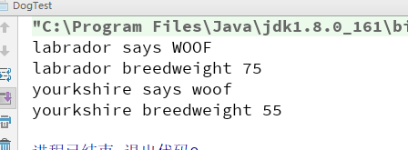

3) Answer questions

4)Error Analysis and Discussion

5 Extending Adapter Classes
1) Source code list

package chapter08.p2;
import javax.swing.*;
/**
* @Description:
* @Author: QiuGuanLin
* @Date: 2018/5/18 10:35
*/
public class Dots
{
//-----------------------------------------------------------------
// Creates and displays the application frame.
//-----------------------------------------------------------------
public static void main (String[] args)
{
JFrame frame = new JFrame ("Dots");
frame.setDefaultCloseOperation (JFrame.EXIT_ON_CLOSE);
frame.getContentPane().add (new DotsPanel());
frame.pack();
frame.setVisible(true);
}
}

package chapter08.p2;
import javax.swing.*;
import java.awt.*;
import java.awt.event.MouseAdapter;
import java.awt.event.MouseEvent;
import java.awt.event.MouseListener;
import java.util.ArrayList;
/**
* @Description:
* @Author: QiuGuanLin
* @Date: 2018/5/18 10:36
*/
public class DotsPanel extends JPanel implements MouseListener {
private final int SIZE = 6;
// radius of each dot
private ArrayList<Point> pointList;
//-----------------------------------------------------------------
// Constructor: Sets up this panel to listen for mouse events.
//-----------------------------------------------------------------
public DotsPanel() {
pointList = new ArrayList<Point>();
addMouseListener(this);
setBackground(Color.black);
setPreferredSize(new Dimension(300, 200));
}
//-----------------------------------------------------------------
// Draws all of the dots stored in the list.
//-----------------------------------------------------------------
@Override
public void paintComponent(Graphics page) {
super.paintComponent(page);
page.setColor(Color.green);
for (Point spot : pointList) {
page.fillOval(spot.x - SIZE, spot.y - SIZE, SIZE * 2, SIZE * 2);
}
page.drawString("Count: " + pointList.size(), 5, 15);
}
@Override
public void mouseClicked(MouseEvent e) {}
@Override
public void mousePressed(MouseEvent e) {
pointList.add(e.getPoint());
repaint();
}
@Override
public void mouseReleased(MouseEvent e) {}
@Override
public void mouseEntered(MouseEvent e) {}
@Override
public void mouseExited(MouseEvent e) {}
}

2) Results data processing
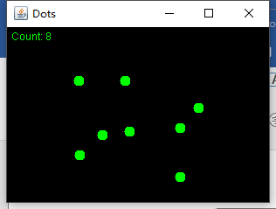

3) Answer questions

4)Error Analysis and Discussion

6 Rebound Revisited
1) Source code list

package chapter08.p3;
import javax.swing.*;
/**
* @Description:
* @Author: QiuGuanLin
* @Date: 2018/5/18 10:47
*/
public class Rebound {
//-----------------------------------------------------------------
// Displays the main frame of the program.
//-----------------------------------------------------------------
public static void main(String[] args) {
JFrame frame = new JFrame("Rebound");
frame.setDefaultCloseOperation(JFrame.EXIT_ON_CLOSE);
frame.getContentPane().add(new ReboundPanel());
frame.pack();
frame.setVisible(true);
}
}

package chapter08.p3;
import javax.swing.*;
import java.awt.*;
import java.awt.event.ActionEvent;
import java.awt.event.ActionListener;
/**
* @Description:
* @Author: QiuGuanLin
* @Date: 2018/5/18 10:48
*/
public class ReboundPanel extends JPanel {
private final int WIDTH = 800, HEIGHT = 600;
private final int DELAY = 20, IMAGE_SIZE = 160;
private ImageIcon image;
private ImageIcon image2;
private Timer timer;
private int x, y, moveX, moveY;
private int x2, y2, moveX2, moveY2;
//-----------------------------------------------------------------
// Sets up the panel, including the timer for the animation.
//-----------------------------------------------------------------
public ReboundPanel() {
timer = new Timer(DELAY, new ReboundListener());
// 使用绝对定位确认文件位置
image = new ImageIcon("C:\\Users\\QGL-XPS\\Desktop\\face.png");
image2 = new ImageIcon("C:\\Users\\QGL-XPS\\Desktop\\face.png");
x = 0;
y = 40;
moveX = moveY = 3;
x2 = 200;
y2 = 40;
moveX2 = 6;
moveY2 = -6;
setPreferredSize(new Dimension(WIDTH, HEIGHT));
setBackground(Color.black);
timer.start();
}
//-----------------------------------------------------------------
// Draws the image in the current location.
//-----------------------------------------------------------------
@Override
public void paintComponent(Graphics page) {
super.paintComponent(page);
image.paintIcon(this, page, x, y);
image.paintIcon(this, page, x2, y2);
}
//*****************************************************************
// Represents the action listener for the timer.
//*****************************************************************
private class ReboundListener implements ActionListener {
//--------------------------------------------------------------
// Updates the position of the image and possibly the direction
// of movement whenever the timer fires an action event.
//--------------------------------------------------------------
@Override
public void actionPerformed(ActionEvent event) {
x += moveX;
y += moveY;
if (x <= 0 || x >= WIDTH - IMAGE_SIZE) {
moveX = moveX * -1;
}
if (y <= 0 || y >= HEIGHT - IMAGE_SIZE) {
moveY = moveY * -1;
}
x2 += moveX2;
y2 += moveY2;
if (x2 <= 0 || x2 >= WIDTH - IMAGE_SIZE) {
moveX2 = moveX2 * -1;
}
if (y2 <= 0 || y2 >= HEIGHT - IMAGE_SIZE) {
moveY2 = moveY2 * -1;
}
if (Math.sqrt((x - x2) * (x - x2) + (y - y2) * (y - y2)) <= image.getIconWidth()) {
System.out.println("x= " + x + " y= " + y + " x2= " + x2 + " y2= " + y2);
if (Math.abs(x2 - x) >= Math.abs(y2 - y)) {
moveX = moveX * -1;
moveY = moveY * -1;
}
if (Math.abs(x2 - x) <= Math.abs(y2 - y)) {
moveY = moveY * -1;
moveY2 = moveY2 * -1;
}
}
repaint();
}
}
}

2) Results data processing
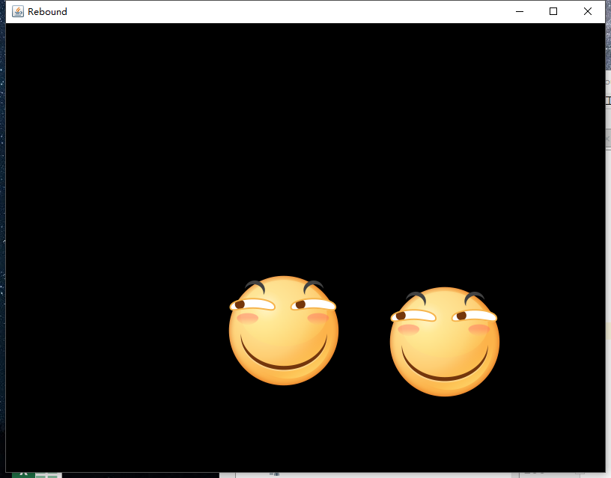

3) Answer questions

4)Error Analysis and Discussion

1 Exploring Inheritance
1) Source code list

2) Results data processing

3) Answer questions

4)Error Analysis and Discussion

